- CHANGES IN CATEGORIES - Categories are not taking in the Designs
- Go to Occasions & go to Funeral Category -- It doesn't show any designs - In spite of we mentioning the category against each & every design

- Handbunch category is missing
___________________________________________________________________

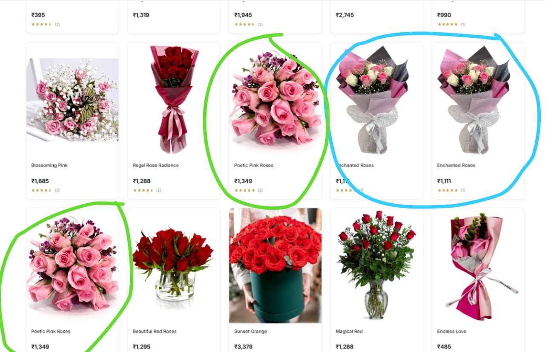
- On the same page - Products are visible twice
On Dashboard - in the Products Page - We checked if the product has been listed twice - But NO --- Its Listed one time only - Still many items are visible Twice on the same page - in the main Website / Category Page also
___________________________________________________________________

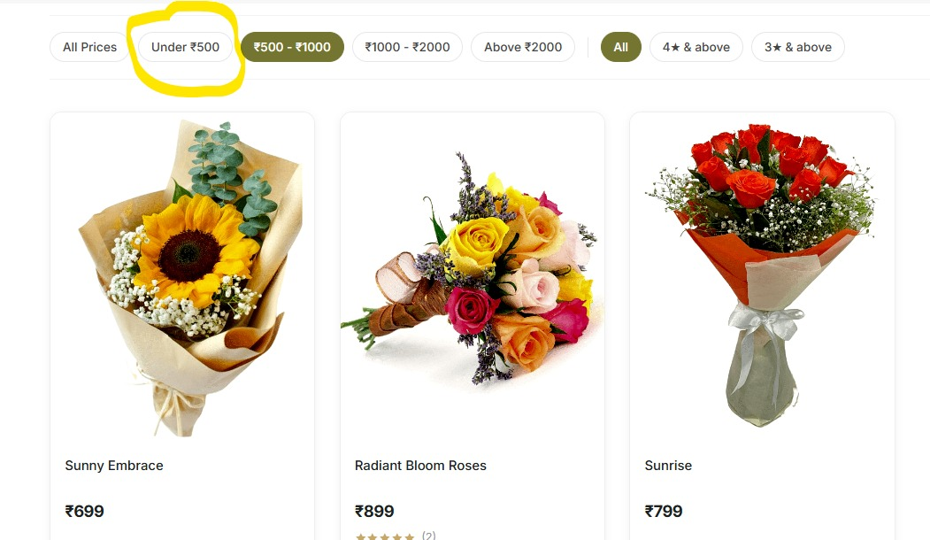
- How to remove this category --- ? As we dont have any Products below 500
Doesn't make sense we keep this category - Highlighted in Yellow
___________________________________________________________________

- Add this note on every product page - like we have did for our earlier website
(Note: Flower colors may vary based on seasonal availability and the freshness of blooms. Rest assured, any substitutions will be carefully selected to maintain the overall style, quality, and beauty of the arrangement.)
___________________________________________________________________

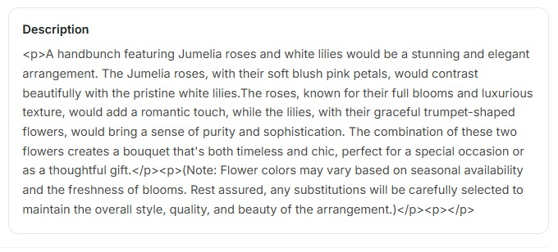
- Also remove this <p> - code language from all products description
___________________________________________________________________

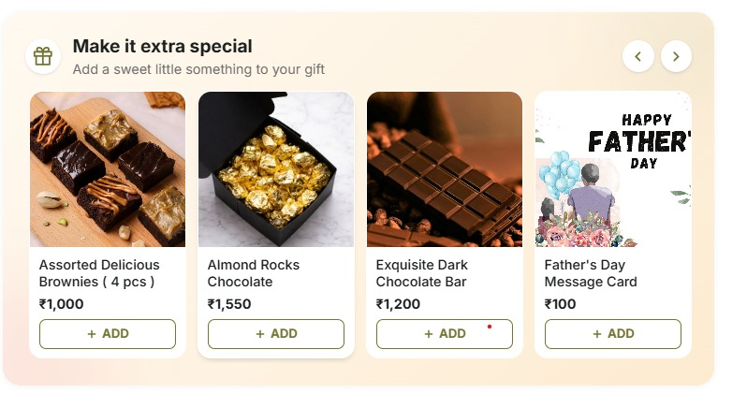

- Can we move the Father's Day card to the first position and reorder it accordingly? - REORDER ADDON LIST
___________________________________________________________________

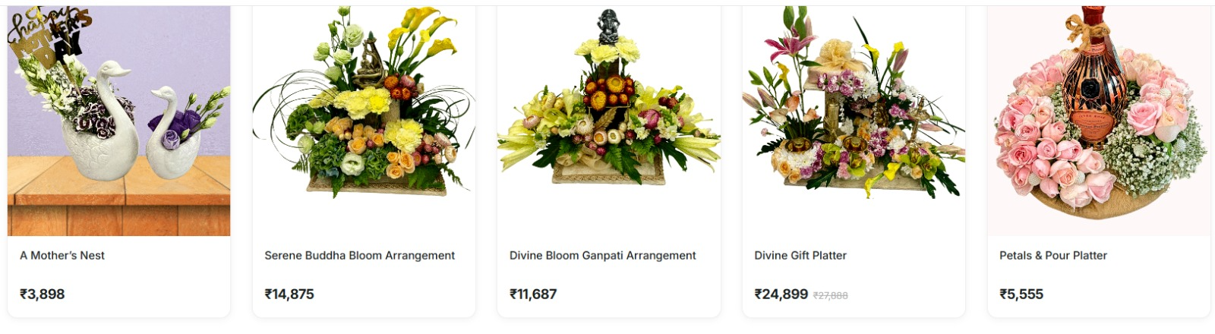
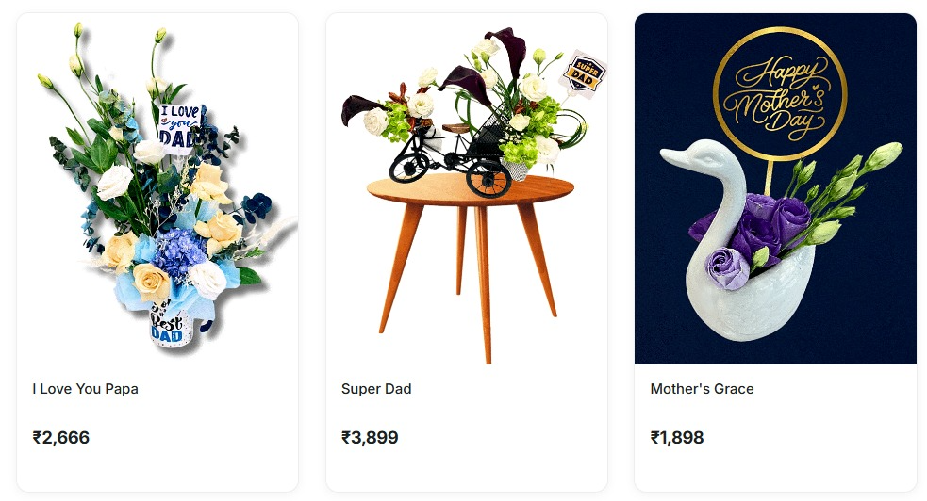
- Pictures Pixels are getting distorted
They are not opening - All these products are also not opening
___________________________________________________________________
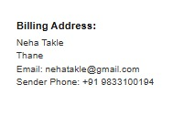
Kindly check the sender number section. It is showing the Pretty Petals number, but it should display the sender's phone number.
___________________________________________________________________

1.Please enhance the quality of the product images, reduce the file size, and review them

2.Required Changes in Delivery Challans & Invoice
Please make the following changes as per the attached image:
- Add the logo on the Delivery Challan (DC) – (Logo PNG file is shared)
- Add the logo on the Invoice.
- On the Delivery Challan – add the sender’s phone number.
- On the Delivery Challan – remove duplicate details (receiver name, phone number, delivery date, and PIN code).
- On the Delivery Challan – remove the bottom-line mentioning link - /packingslip….
- On the Invoice – the shipping address is incorrect, as the receiver’s details have been mentioned instead of the sender’s. Kindly correct this.
- On the Invoice – add “Pretty Petals +91 9833100194” above the GST number.

3.Reena Ma’am has explained on group regarding customers review and order delivered mail –
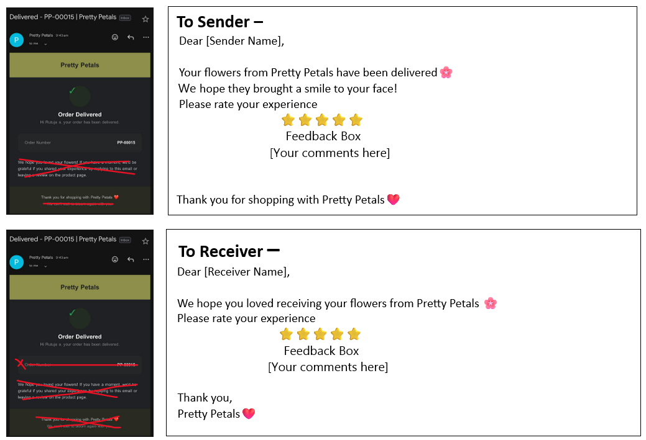
IMPORTANT NOTE –
1.Ensure Google reviews and website reviews are synchronized and include a 5-star rating option.
2.If possible, please ensure that only reviews with 3 stars and above are visible on Google and the website. Reviews below 3 stars can be collected and stored in the backend for internal review and follow-up.
3.Please add the star rating message to the WhatsApp notifications sent after order delivery. This should be sent to both the sender and the receiver
4.Create a dedicated review page for offline customers as well. From which 3 & 3 stars above reviews will show on google and website

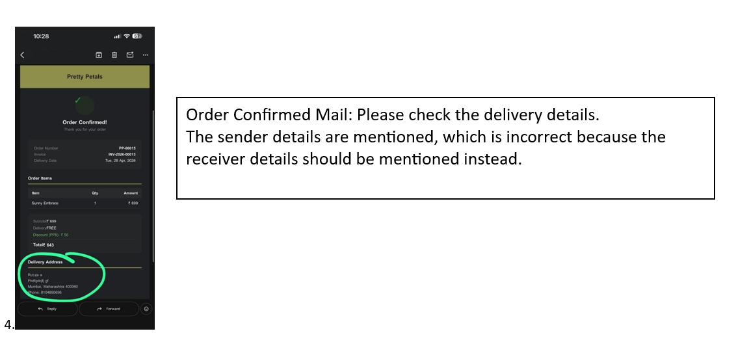

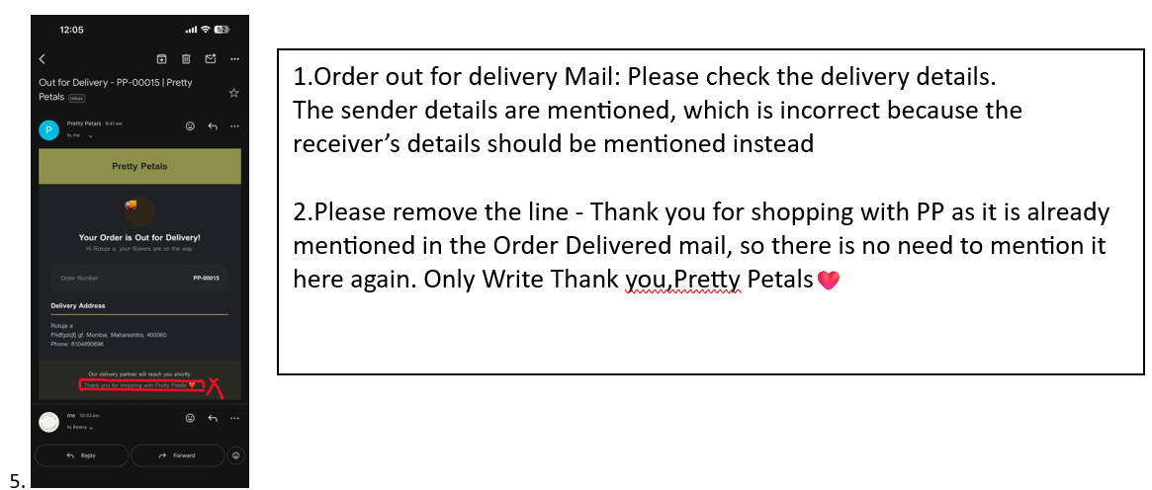

6. Customers are not receiving the Order Processing Status on WhatsApp or via email – Kindly create it

7.The Order delivered status should not be sent to 9833100194 (Pretty Petals number) or support@prettypetals.com email. Only we need Order received message on w/s and on support mail id

8.Guide us on how to create a DELIVERY STATUS LINK that we can send to our delivery boys.
Make sure it is a simple process with only 1 to 2 steps maximum as the delivery person are not that much tech savvy.
OR Can we include the delivery tracking link in the WhatsApp order received message -ONLY FOR US NOT FOR CUSTOMER

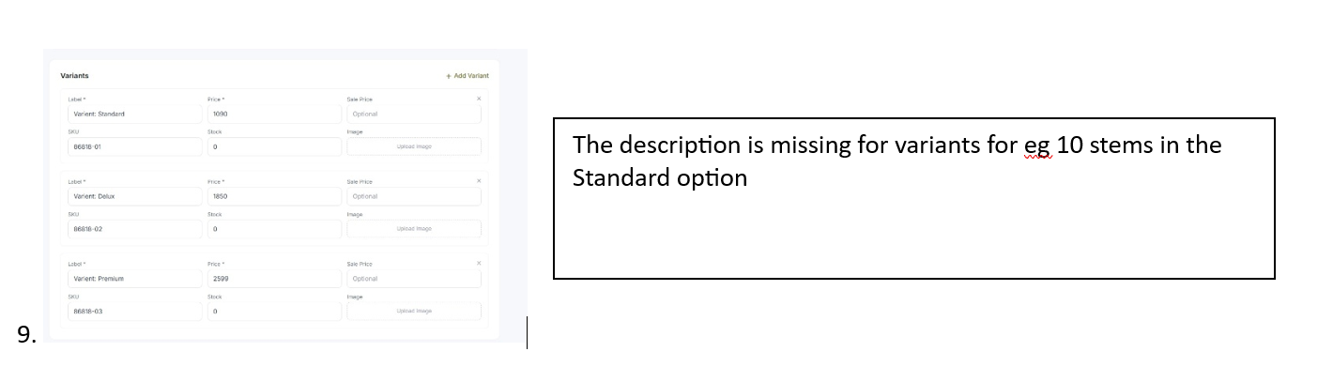

10.Create an Automated Email Reminder for customers one day prior to their order date.
Example: If an order is placed on 24th April 2025, the customer should receive a reminder on 23rd April 2026 with order details and recipient information.
Template Example:
Hi (Sender Name),
Greetings from Pretty Petals 🌸.
This is a reminder that you placed an order with us for (Receiver Name) on 24th April 2025.
Would you like to send flowers again this year?

11.Replace the Valentine category with Premium Flowers on the main page.

12.Enable Auto-apply coupons & all available coupons should appear as a dropdown in the coupon section on the checkout page.

13.Display a pop-up message for free delivery on orders above ₹10,000 when customers select Thane, Navi Mumbai, Dahisar, or Virar as the delivery location.

